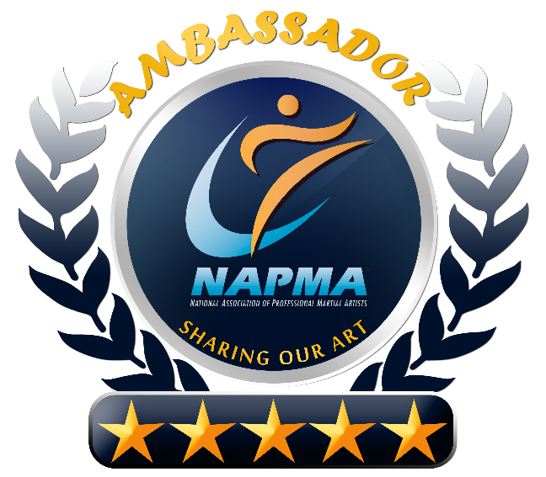
Be Our
Ambassador!
We are sincerely grateful and honored that you have chosen our school and our program to help you achieve your personal goals, and those of your family.
Our mission is to have an enormous positive “ripple” effect in our community, and make a significant, lasting positive impact in the lives of our students and their families.
I’m sure you’ll agree, this program and the empowering, energizing, uplifting environment we create here is MUCH more than just a “work out” or “seasonal activity”. As such, we know that there are a lot of other people in our community that could greatly benefit from our program if we just knew who they were!
We want to serve more students like you, and families like yours, so we created the “Ambassador Program”.
The Greatest Compliment You Can
Give Your Instructor is to Refer
a Friend to Our Program!
Do you know someone who could benefit from the many
benefits of this martial arts program?

- Greater Sense of Self Esteem
- Stronger Self Confidence
- A Powerful System of Self Defense
- A Positive Peer Group
- Greater Cardio Vascular Fitness
- Improved Flexibility
- Laser Sharp Focus
- Outrageous Fitness
- Less Stress
- Lower Resting Heart Rate
- Camaraderie
- And So Much More!!
Perhaps someone you work with, go to school with, your best friend, your uncle or brother in law, or someone on your softball team?
If you feel that we’re doing a good job here at the school, and you feel that someone you know could benefit from our program too, please give them one of these (included) guest passes.
If your friend chooses to begin their own journey toward achieving their Black Belt (like you), not only will we be eternally grateful, you’ll also earn our “Ambassador Award”.

